Hawai’i Department of Health
December 4^{h}, 2019

PROJECT FINAL REPORT
Green Business Query
Tai Bui

TABLE CONTENTS
I. SUMMARY 3
II. INTRODUCTION 4
III. NEEDS/PROBLEM 5
IV. GOALS/OBJECTIVES 5
V. Procedures/Scope of Work 5
VI. TIME/TABLE 6
VII. EVALUATION 7
VIII. DATA DICTIONARY 7
IX. FINAL REPORT 8
X. APPENDIX 9

- Summary
This document include all information regarding the development process of the Green Business web application. Green Business is a web application that allows users to conveniently search for sustainable businesses listed by the Hawai’i Department of Health. Furthermore, the web app also acts as a connection between the general public with the local business owners by providing business information, and search locations. Besides the development of the web app, the Hawai’i Department of Health also requests for future maintenance and updates if needed. To match with the department’s current system, the Green Business web app will be developed with HTML, CSS as front-end and NodeJS as back-end server. Moreover, I also use MariaDB as the database to store all businesses’ data for this web app.

- Introduction
The project that I was requested with is to create a web application for Hawaii Green Business Program. The client for whom the work will be done for is Travis Hiramoto from the Hawaii Department of Health and Environmental Management, Solid and Hazardous Waste Branch. The system will need to address two main user groups; general users such as tourists, and business users. The main goal of this web application is to allow general users to explore nearby green businesses, and to provide businesses a convenient way to present their information toward public users as an environmental-friendly organization. In turn, the development of this application will encourage businesses to become green certified so that they will have this additional avenue of advertisement for their business.

- Needs/Problems
One of the major problems of this project is that the client will not be able to participate during the development process. All functional requirements will be developed based on client’s abstract description. On the other hand, the Department of Health currently has another web app that can provide similar functions to this project; however, it was built many years ago with certain functional limits due to technical restraints. This project needs to be built with today requirements such as ECMA’s standards. Lastly, there is only a single developer on this project and the development time frame is within a month; therefore, the final product is expected to be a functional prototype, represent the query function rather than the entire web application itself.
- Goals/Objectives
The main deliverable will be a prototype web application with functional database. This prototype should have a front-end to display all sustainable businesses’ information as well as a back-end database which store all related data. While the front-end will be built using HTML, CSS and JavaScript, the back-end will be powered by NodeJS and MariaDB database.
- Procedures/Scope of Work
For this Green Business project, I will develop a functioning prototype web application using HTML, CSS, JavaScript and MariaDB database. This web application will allow local green business owners to post their information and be recognized as a local sustainable business. Furthermore, this application also allows the general public users to search for information and location of the approved local sustainable businesses by categories.
- Timetable
 | Description of Work | Start and End Dates
Phase One | - Scrape all necessary data from official website http://greenbusiness.hawaii.gov  - Develop mockup for the page and ERD diagram | November 4th – November 12th
Phase Two | - Redesign Database model  - Start developing script to import data into database  - Research on using AWS to host database | November 13th – November 18th
Phase Three | - Complete script to format SQL commands for importing data  - Complete database hosting by AWS  - Complete individual profile page | November 19th – November 26th
Phase Four | - Work on search engine and listing all companies page  - Research on listing an array of pdf certificates on ejs. If unsuccessful, I will display only the most recent certificate | November 27th – December 6th

- Evaluation
The final product should function properly, meaning users should be able to look for information of any particular sustainable businesses listed by Hawai’i Department of Health using web’s front-end. Furthermore, end-users are also able to search for business by inputting keywords. If keywords are contained within any parts of businesses’ fields such as names, address, or description, the app will return a list of businesses that have those keywords. On the other hand, it is also possible for admin to perform any query functions upon the application’s database such as insert, delete, select, etc. The project will be evaluated by professor Noeli Boedo of Hawai’i Pacific University. The evaluation process will be done during the final week of the semester.
8. Data Dictionary
Table Name | Attribute | Contents | Type | Format | Required | PK
BUSINESS | BUS_ID | Business ID code | NUMERIC | 999 | Y | PK
BUSINESS | BUS_CATEGORY | Business Category | VARCHAR(20) | Xxxxx | Y
BUSINESS | BUS_NAME | Name of business | VARCHAR(100) | Xxxxx | Y
BUSINESS | BUS_ADDRESS | Business address | VARCHAR(100) | Xxxxx | Y
BUSINESS | BUS_CITY | City location | VARCHAR(20) | Xxxxx | Y
BUSINESS | BUS_ZIP | Zip code | VARCHAR(20) | Xxxxx | Y
BUSINESS | BUS_CONTACT | Phone number | VARCHAR(15) | Xxxxx | Y
BUSINESS | BUS_DESCRIPTION | Business detail | VARCHAR(200) | Xxxxx | Y
 | BUS_LOGO | Link to logo file | VARCHAR(100) | Xxxxx | Y
 | BUS_CERT | Link to pdf certifications | VARCHAR(100) | Xxxxx | Y

9. Final Report
The Hawai’i Green Business web application prototype has been completed. This project includes two main functions including displaying individual business’ profile pages as well as a searching for businesses according to input keywords. The front-end of this web app uses HTML, CSS, JavaScript and EJS. The script was connected to the app’s database using Express and MySQL which are NodeJS’s packages. The database I used in this project is MariaDB and was hosted by Amazon Web Services (AWS). On the other hand, I also use Python to process .png and .pdf files to format MySQL commands to easing data input process. The database model was adjusted to eliminate the CERTIFICATE entity and add a new column BUS_CERT in BUSINESS entity. This new column will contain the name of the certification file corresponding to the appropriate business. As it is difficult to display multiple pdf files in one single profile page, I decided to make appropriate adjustment to simplify the front-end process. This project is a great experience for me to work with database ERD models, hosting a database using cloud service, as well as to establish connection between the app and the database using NodeJS’s Express.

10. Appendix
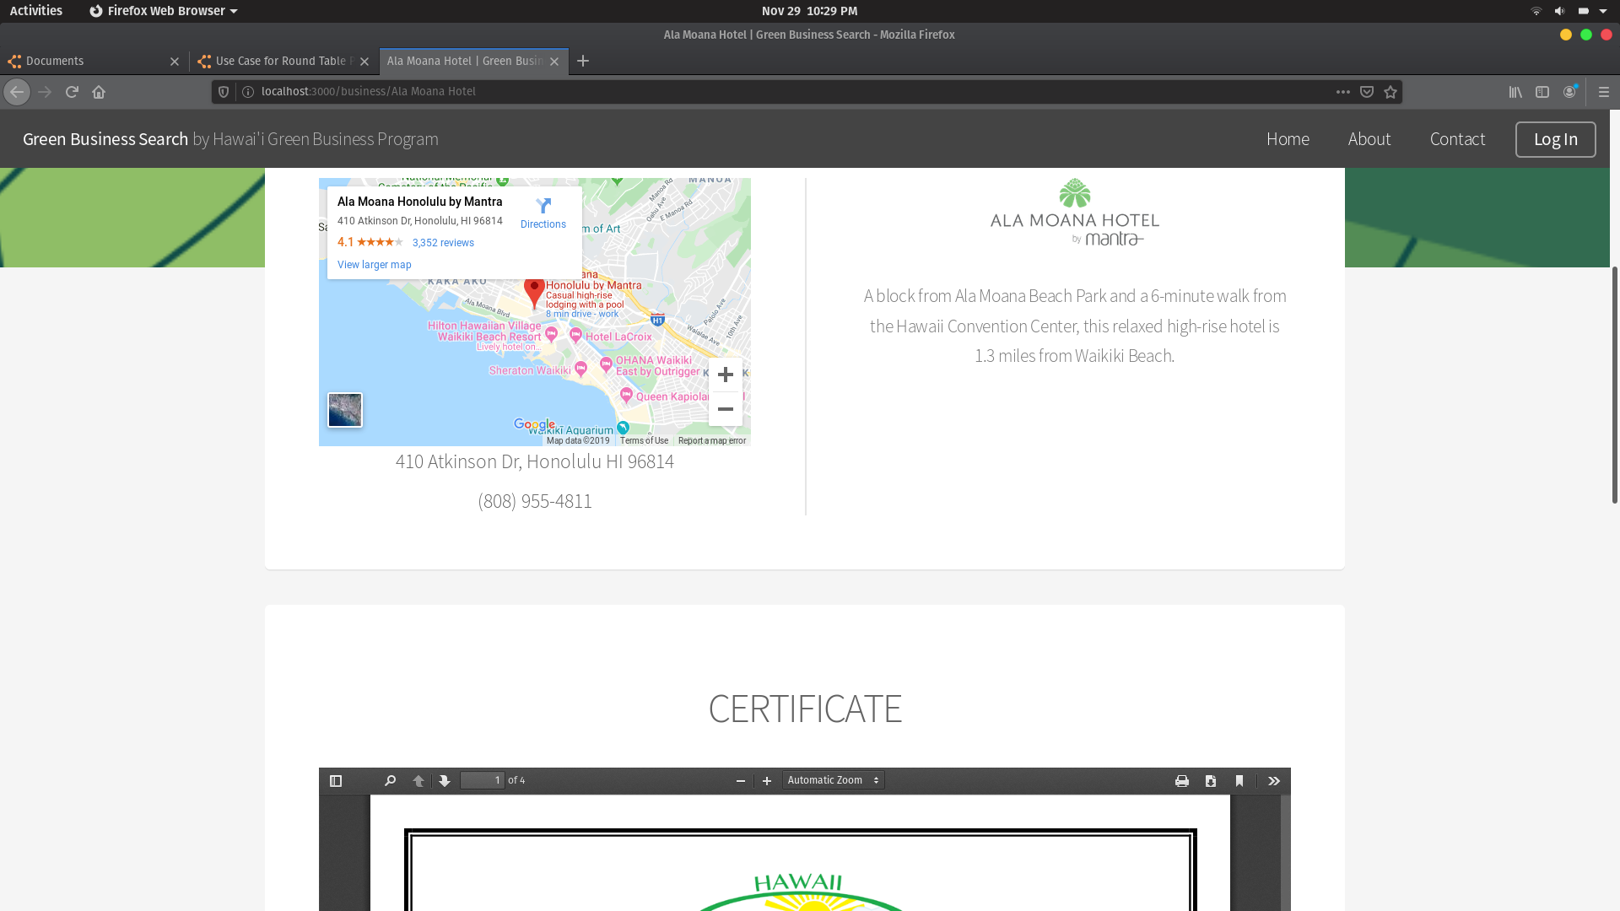
Figure 1: Individual Profile Page

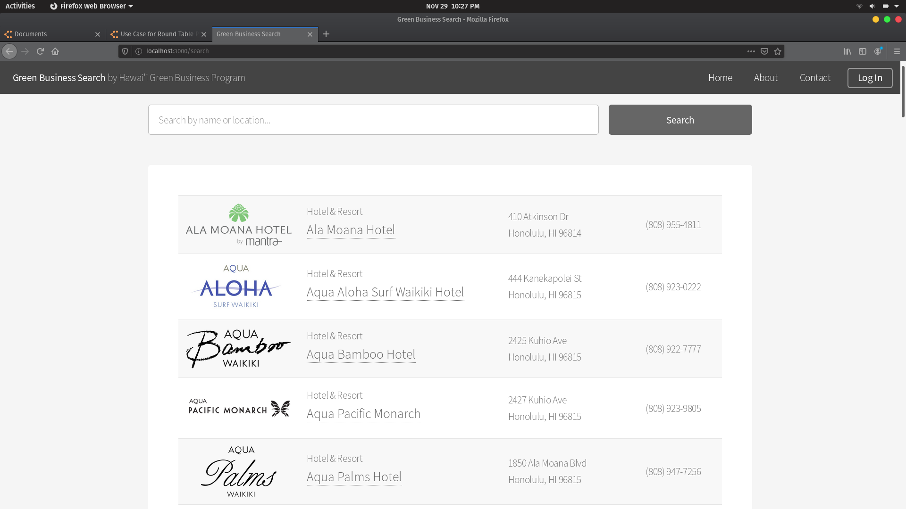
Figure 2: Aggregate Search Page

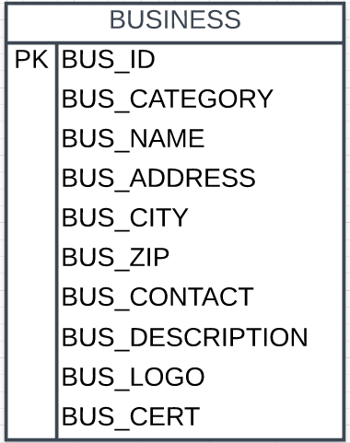
Figure 3: ERD model

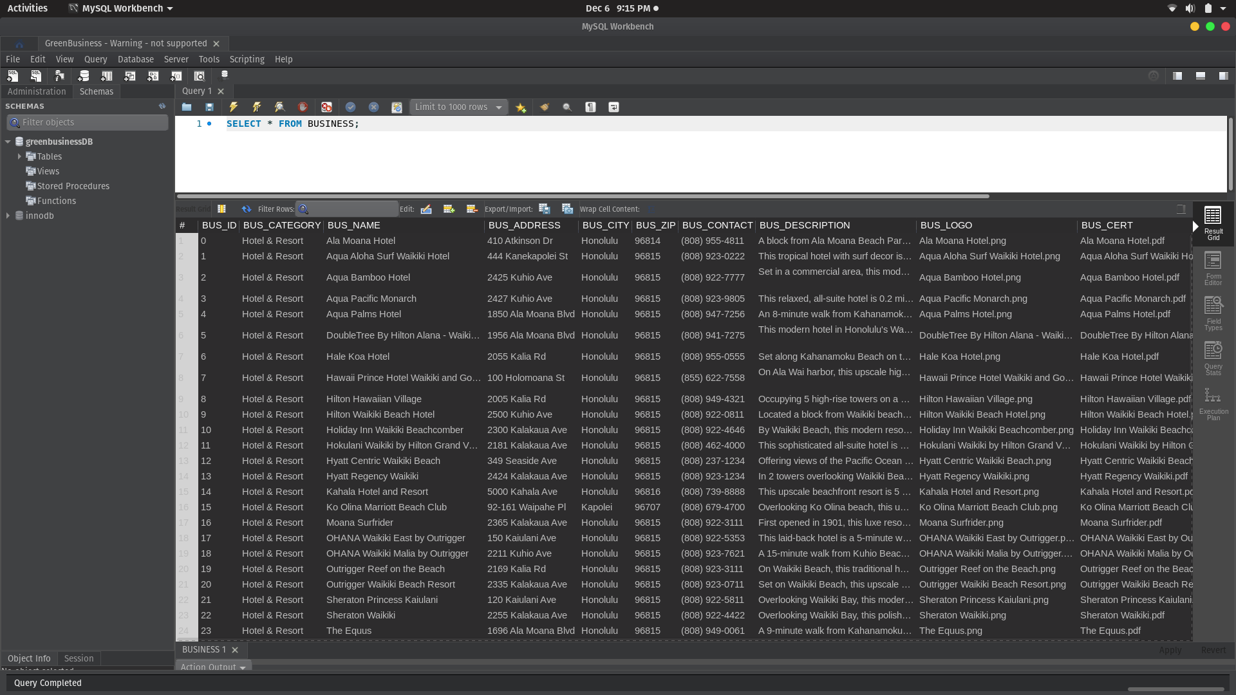Figure 4: Business Entity

